Project Design Phase-II

Data Flow Diagram & User Stories

|  |  |
| --- | --- |
| Date | 28 October 2022 |
| Team ID | PNT2022TMID05580 |
| Project Name | Plasma Donor Application |
| Maximum Marks | 4 Marks |

# Data Flow Diagrams:

A Data Flow Diagram (DFD) is a traditional visual representation of the information flows within a system. A neat and clear DFD can depict the right amount of the system requirement graphically. It shows how data enters and leaves the system, what changes the information, and where data is stored.

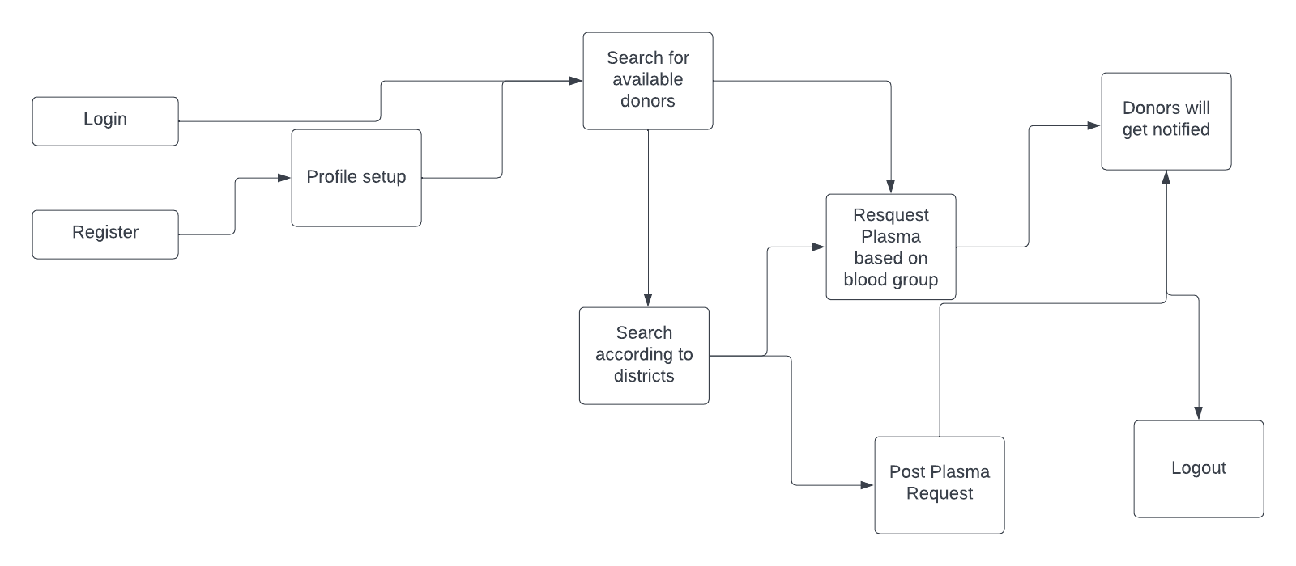

# 

# User Stories

|  |  |  |  |  |  |  |
| --- | --- | --- | --- | --- | --- | --- |
| **User Type** | **Functional Requirement**  **(Epic)** | **User Story Number** | **User Story / Task** | **Acceptance criteria** | **Priority** | **Release** |
| Customer (Web user) | Access | USN-1 | As a user, I can setup a profile, and basic details by signing in. | I can access my account / dashboard | High | Sprint-1 |
|  |  | USN-2 | As a user, I will post for plasma requirement. | I can perform several tasks in the application | Medium | Sprint-1 |
|  |  | USN-3 | As a donor, I can register my willingness through this application. |  | Medium | Sprint-1 |
| Administrator | DBMS | USN-4 | As a administrator, I can keep the applications of your organization relies on running. | I can perform various modifications in the applications. | High | Sprint-1 |